DIFFERENT SCENARIOS OF LIMITS
Property-Owners Ins. Co. & Auto-Owners Ins. Co.(PKG)
1134pkg202507300504134009_pkg_ct00.pdf
Page # 9
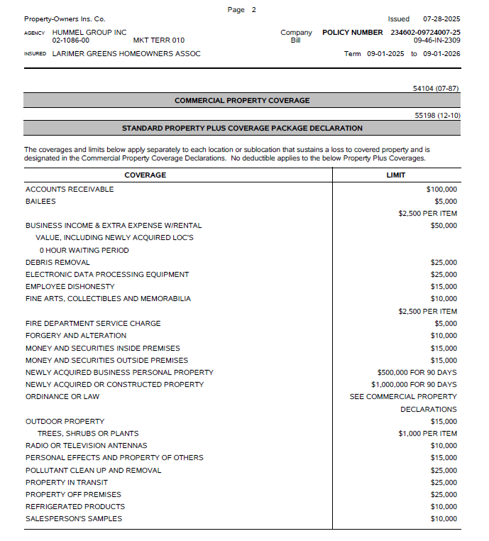

Page # 10
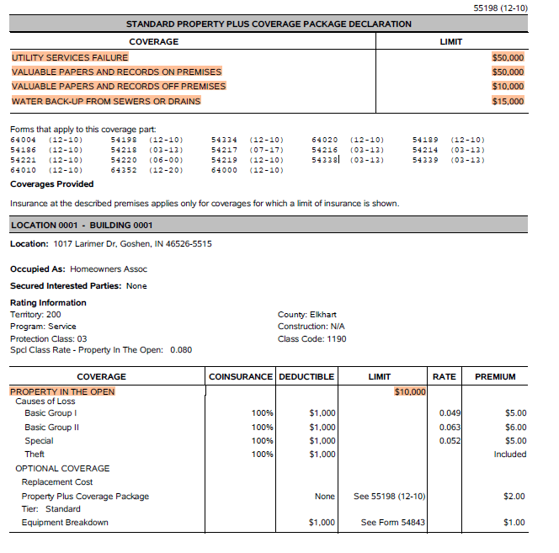

Page # 11

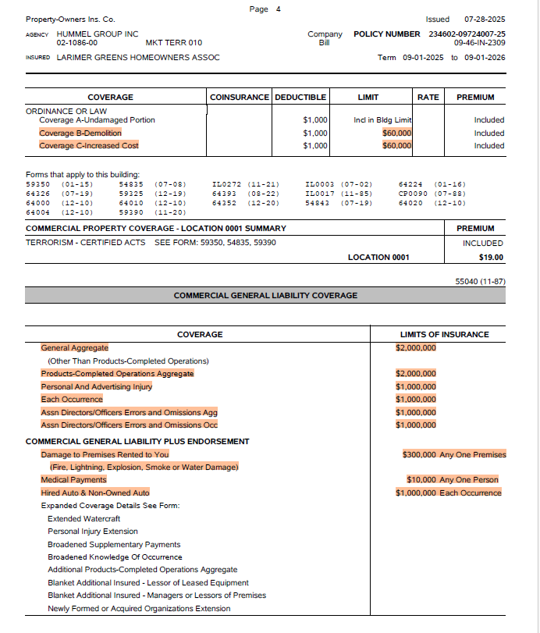

MAXUM INDEMNITY COMPANY - PROPERTY
1150prp202507292330136001_prp_ct00.pdf
Page # 12
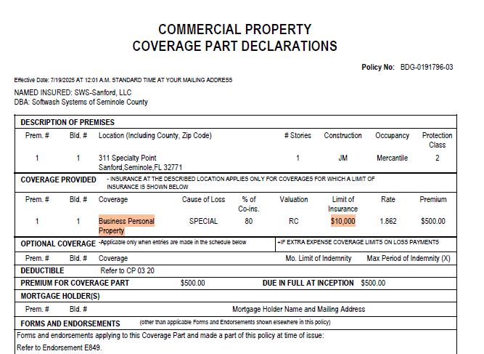
Page # 73
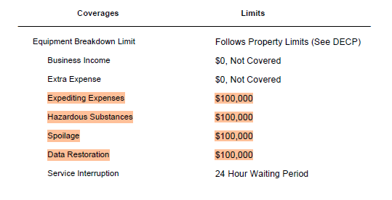

Page # 47
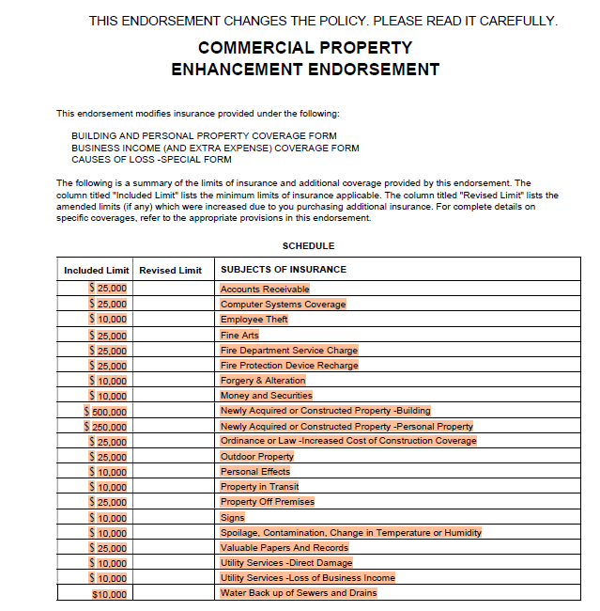
1147prp202507312310545_CT.PDF
Page # 44
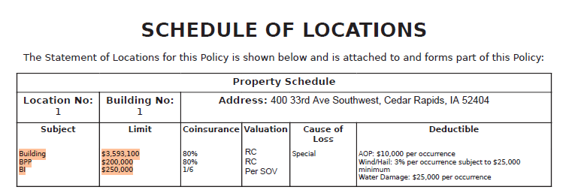
FEDERAL INSURANCE COMPANY - AUTO
1018aut202505310536405_CT.PDF
Page # 14
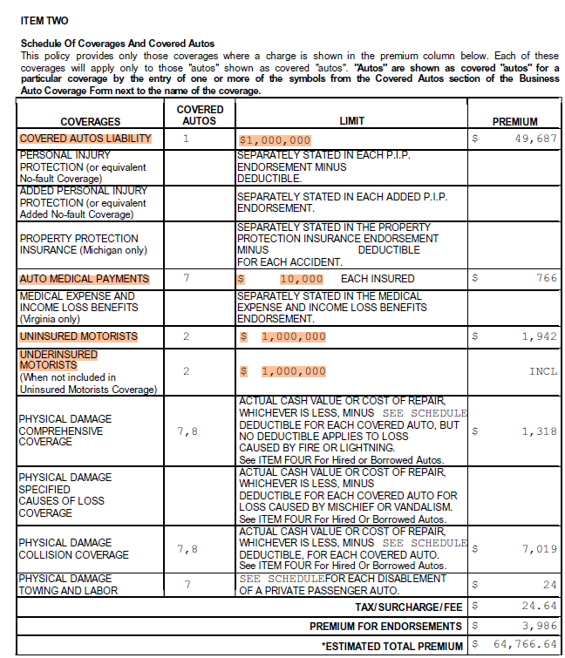

Page # 15
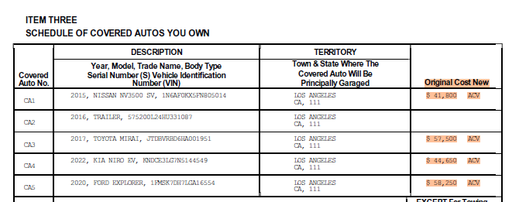
Page # 16
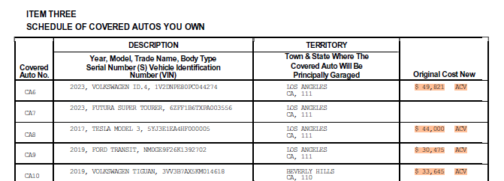
Page # 17

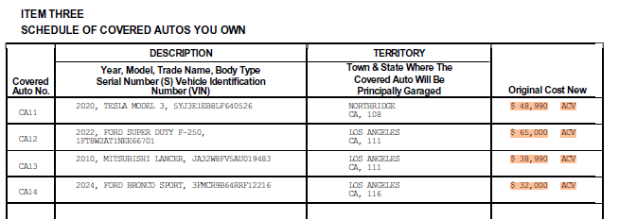

Page # 22
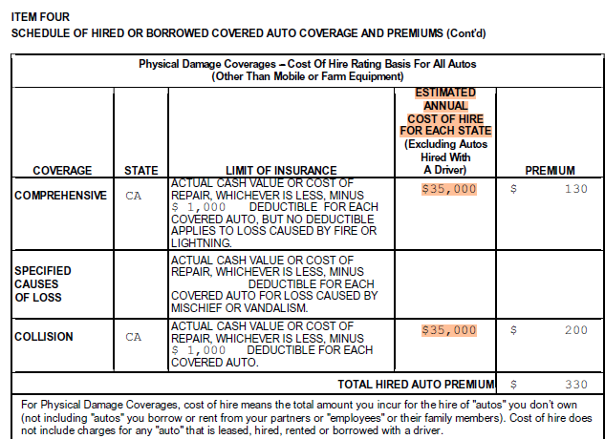
Page # 76
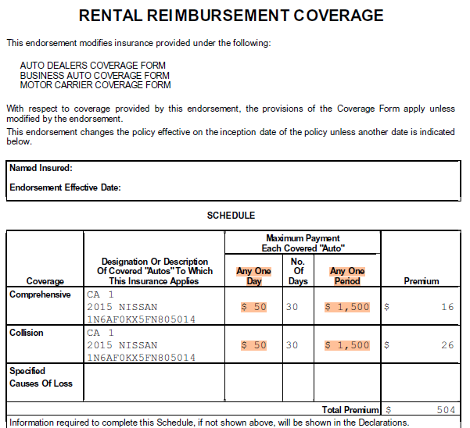
Page # 100
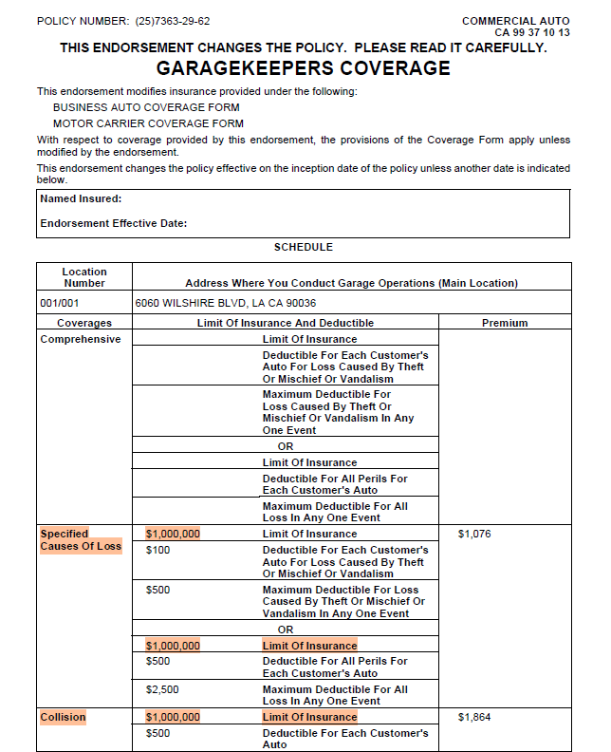

1090csr1202505062125209003_CT.pdf
Page # 73
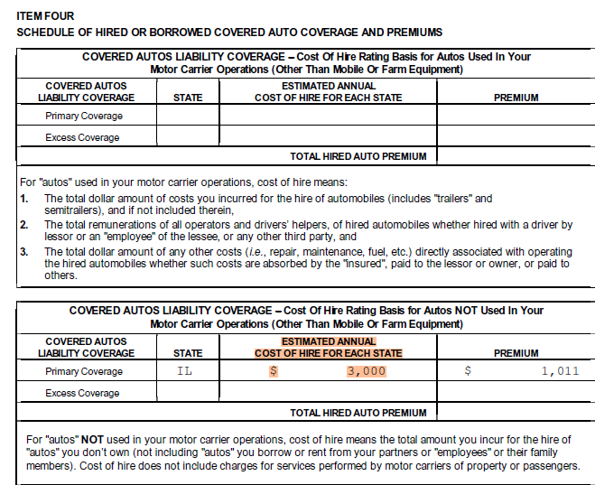
Page # 78
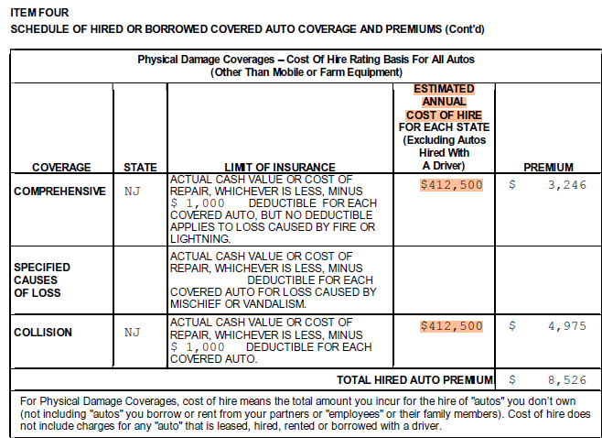
Page # 83
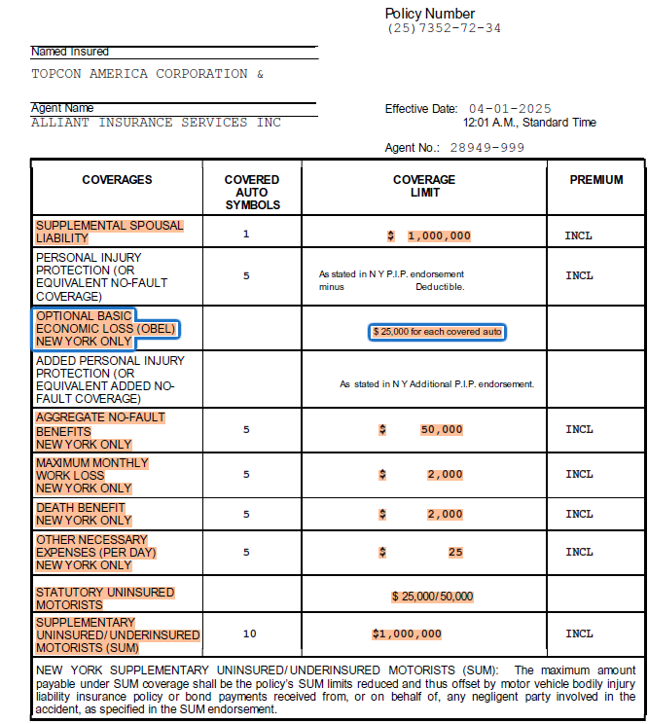

Page # 84
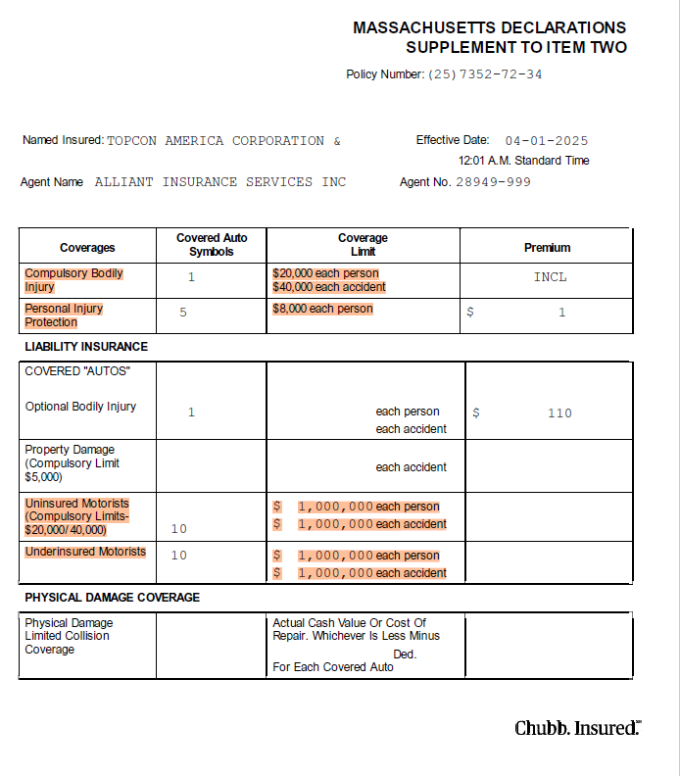

Page # 89
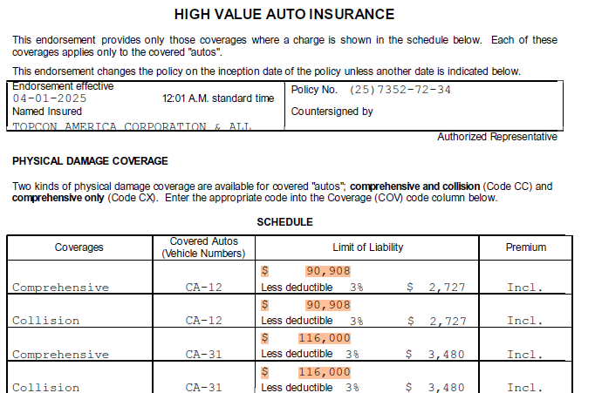
Page # 476
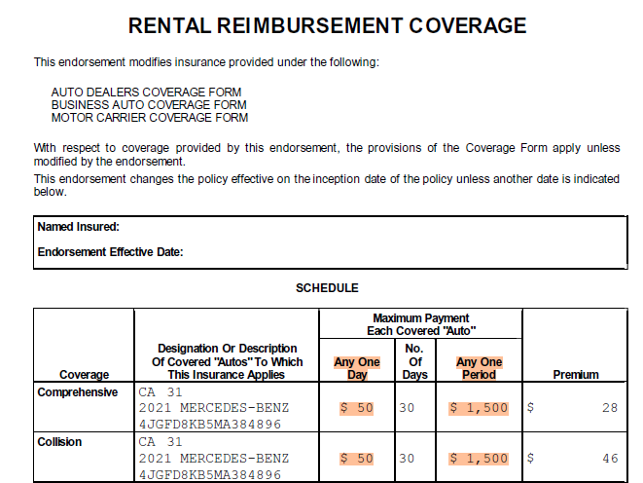
AUTO-OWNERS INS. CO.
Page # 14
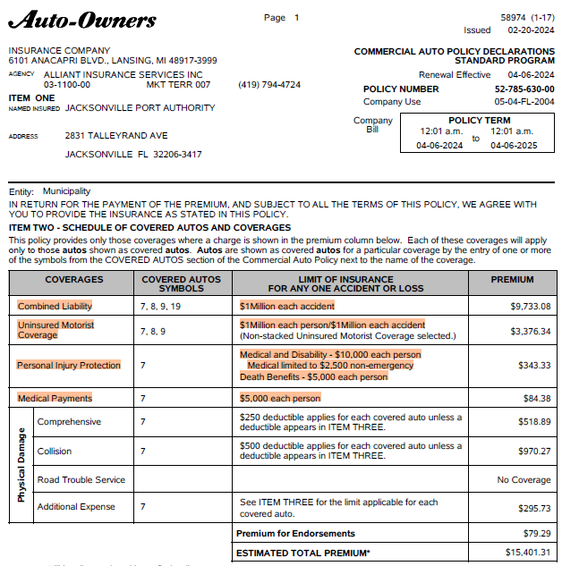

Page # 11
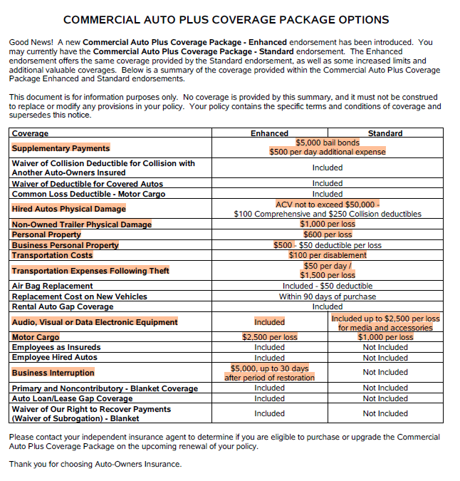

TRAVELERS PROPERTY CASUALTY COMPANY OF AMERICA (Inland marine)
1090boi202507311215013005_CT.pdf
Page # 16
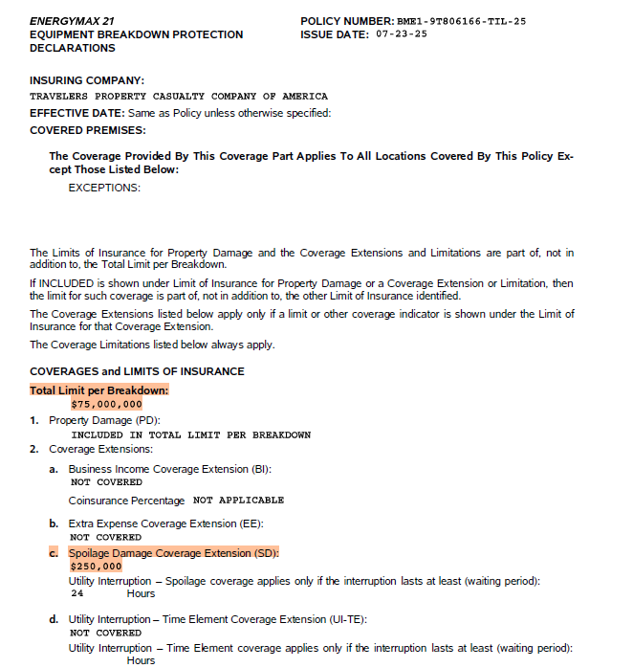

Page # 17
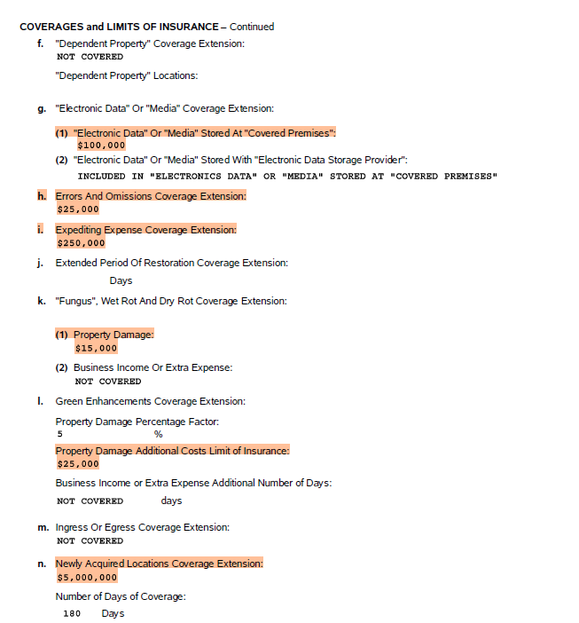
Page # 18
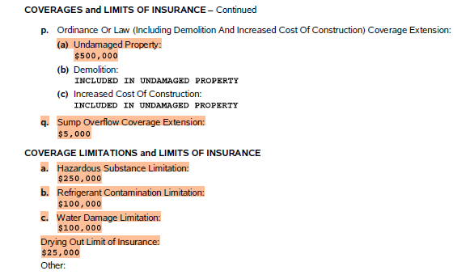
1138ilm202507291909089_CT.pdf
Page # 13
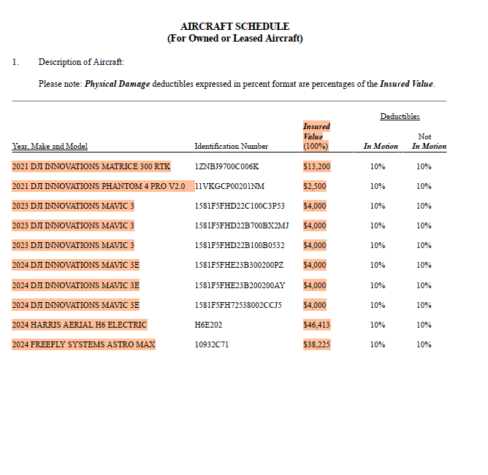

Page # 58
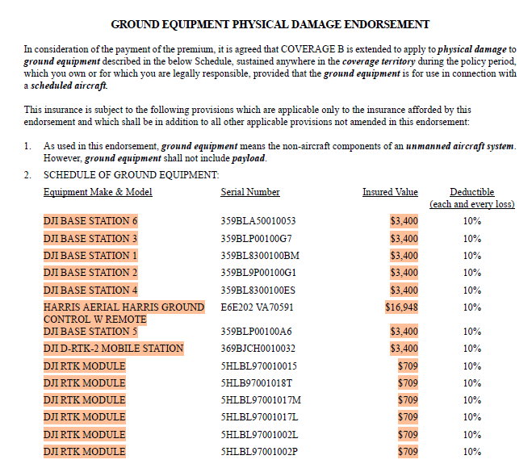
Page # 61

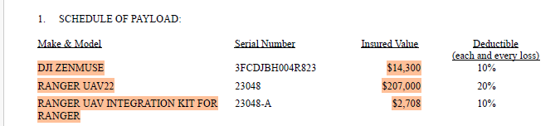

Underwritten by certain underwriters at Lloyd’s (Cyber)
1143cbl202507311438860_CT.pdf
Page # 6
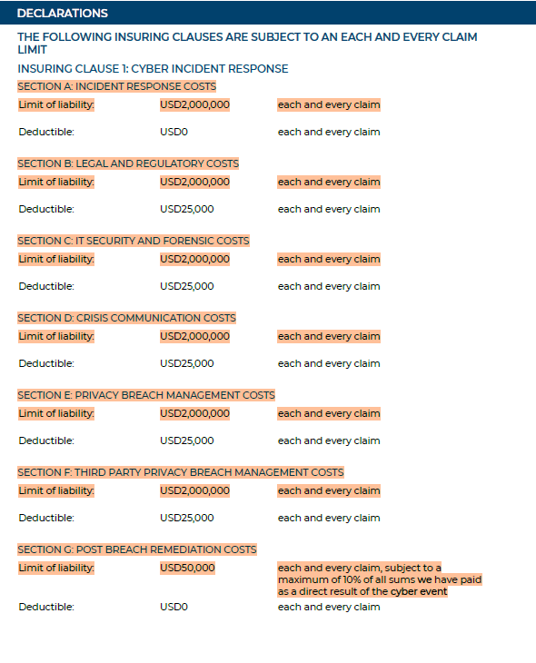

HOUSTON CASUALTY COMPANY
1090cbl202507312106066004_CT.pdf
Page # 2
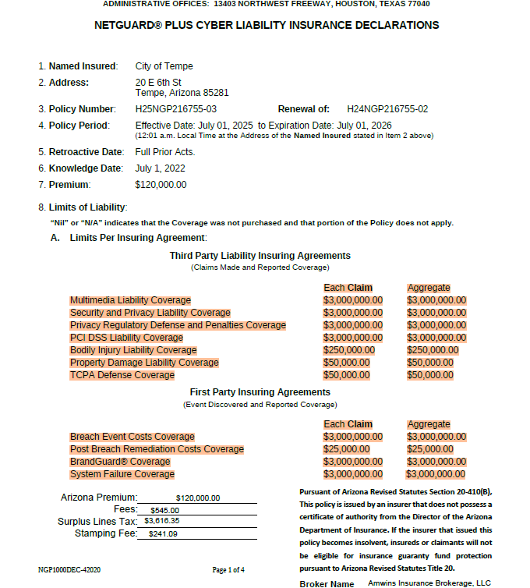

Page # 3

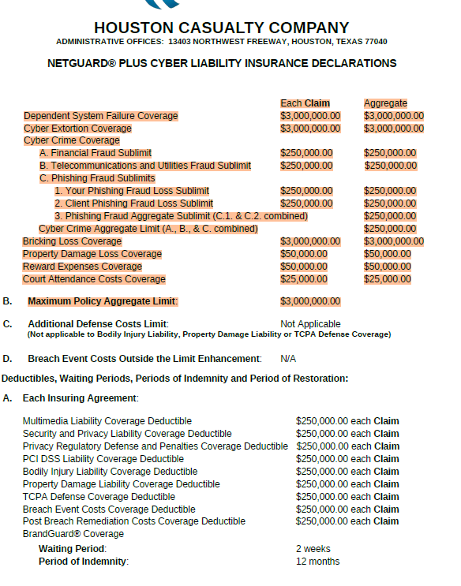

Page # 48
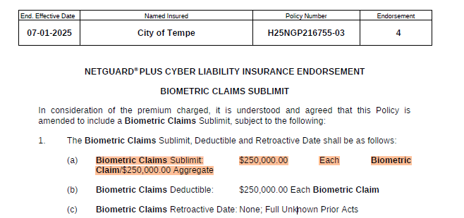

Page # 52
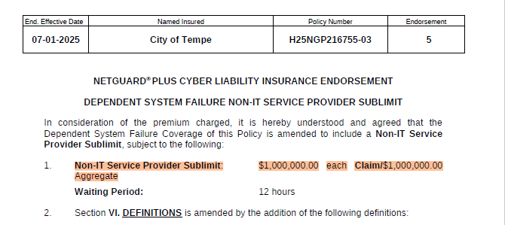

Beazley Excess and Surplus Insurance, Inc.
1142cbl202507311639099_CT.pdf
Page # 4
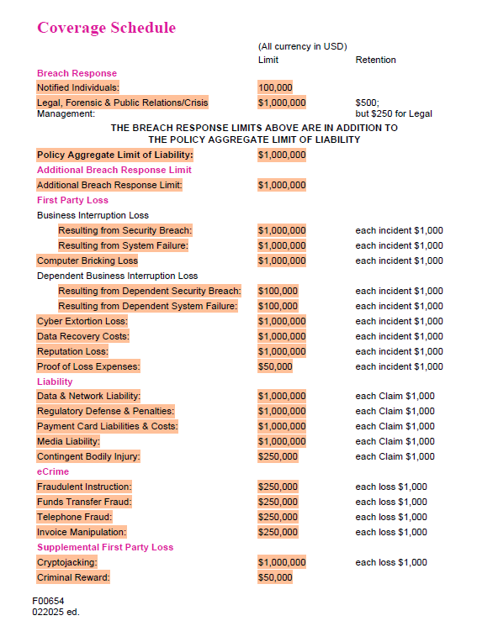

AIG Insurance Company of Canada
1099cbl202507310954888_CT.pdf
Page # 19
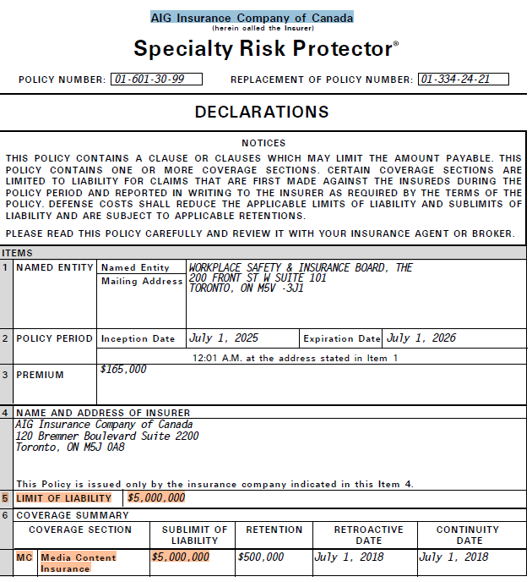
Page # 20
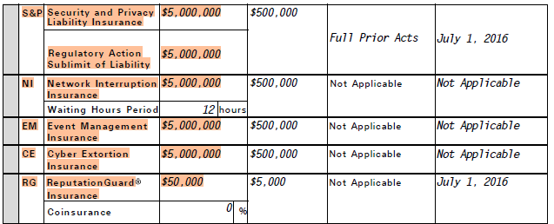
GREAT AMERICAN SPIRIT INSURANCE COMPANY
1162ADD202508010003086007_CT.pdf
Page # 9
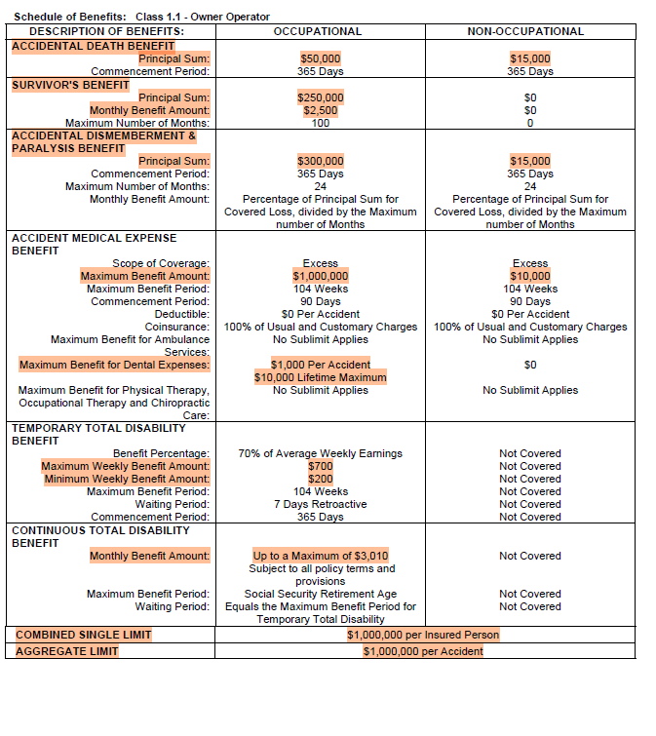

Page # 10
